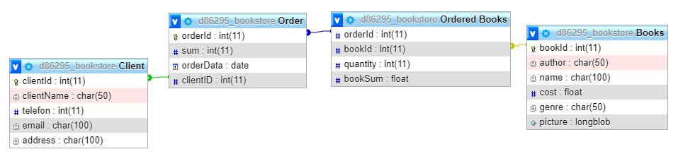

NB! The field that was previously named **‘name’** is now named **‘title’** instead. The change was necessary as it’s not possible to assign a variable with a reserved keyword/property.